- Read the number of hours parked and calculate parking fees using different rates for the first 2 hours, next 3 hours, and remaining hours.

flowchart
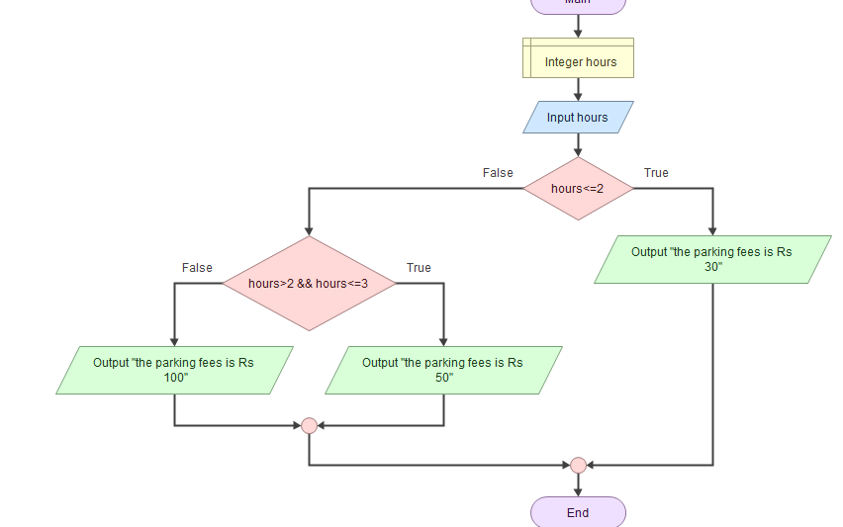

Output:
5
the parking fees is Rs 100

pseudo code:

import java.util.*;
import java.lang.Math;

public class Program {
private static Scanner input = new Scanner(System.in);

public static void main(String[] args) {
int hours;

hours = input.nextInt();
if (hours <= 2) {
System.out.println("the parking fees is Rs 30");
} else {
if (hours > 2 && hours <= 3) {
System.out.println("the parking fees is Rs 50");
} else {
System.out.println("the parking fees is Rs 100");
}
}
}
}

